Absolute Dating Notes
Video questions: http://www.youtube.com/watch?v=bLszCCLN-uw
- What is radioactive decay?
- What does it mean when something is stable or unstable?
- What are some ways we use radioactive things?
Define Absolute Dating: ______________________________________________________________________________
How do we find absolute age? _________________________________________________________________________

What is radioactive decay?
Color the radioactive atoms
=unstable
= stable

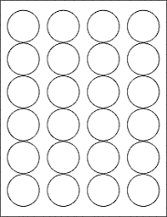

0 half lives
____ radioactive atoms
____ stable atoms
2 half lives
____ radioactive atoms
____ stable atoms
1 half life
____ radioactive atoms
____ stable atoms
3 half lives
____ radioactive atoms
____ stable atoms

All living things contain carbon. This helps scientist when they are trying to determine the age of a fossil. The process used is called Carbon Dating.

A special type of fossil notes:

