 | Earth History Pt 1 Commonly Missed Questions
. | 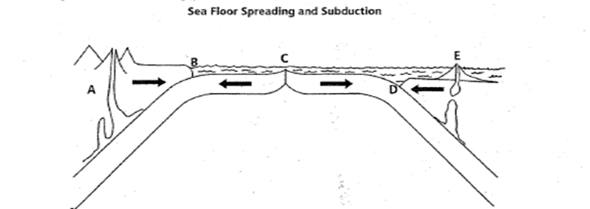  1. Name the type(s) of plates involved in collision D?
 | A. continental-continental
 | B. continental-oceanic
 | C. oceanic-oceanic
. | 2. How did the discovery of magnetic reversals help to support the theory of plate tectonics?
 |  |  | A. it provided more evidence that the plates move away from mid-ocean ridges
 |  |  | B. it proved that the Earth's magnetic poles change place
 |  |  | C. it allowed hotspots to be used to track plate movement
 |  |  | D. it showed that Earth’s magnetic field changes over time
3. |  |  | Which of the following best describes a tectonic plate?
 |  |  |  | A. a large slab of the asthenosphere that moves over the Earth’s surface.
 |  |  |  | B. a part of the asthenosphere in which convection takes place
 |  |  |  | C. a slab of Earth’s crust and upper mantle that moves over Earth’s surface.
 |  |  |  | D. a large slab of crust where convection takes place.

4. | At which of these points is crust neither created nor destroyed?
 | A. divergent
 | B. convergent
 | C. transform
 | D. mid-ocean ridge
5. | Earth’s magnetic reversals are recorded in…
 | A. sea-floor rock
 | B. mantle
 | C. deep ocean trenches
 | D. asthenosphere

6. | New crust forms along a…
 | A. divergent boundary
 | B. convergent boundary
 | C. subduction zone
 | D. ocean trench
7. | Convection currents in he Earth's mantle are believed to be responsible for
- Ocean currents
- Uneven surface heating
- Climate change
- Crustal plate movement
8. | Tectonic plates are destroyed at which kind of plate boundary?
 | A. divergent
 | B. convergent
 | C. magnetic
 | D. transform

