

+



+

**Cohesion Adhesion**

Water _____________ with other water Water _______________________________ substance

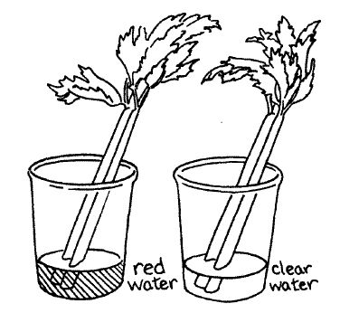 Surface Tension Capillary Action

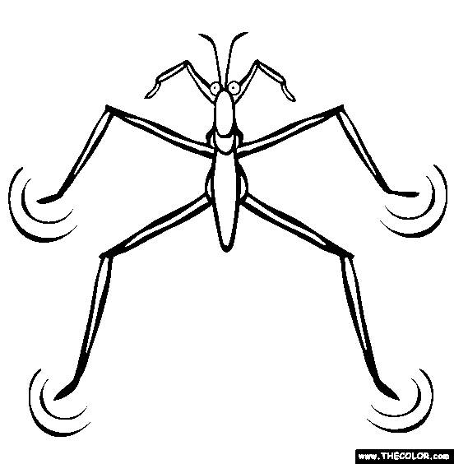

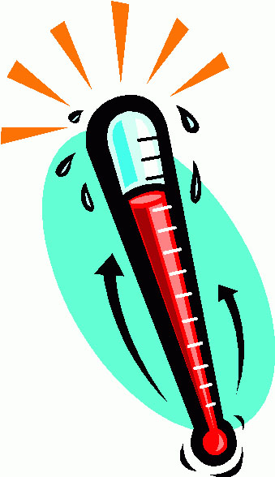 Specific Heat Water Hardness