**GEOLOGIC TIME**

DIVISIONS OF TIME

EONS –

ERAS –

PERIODS –

EPOCHS -

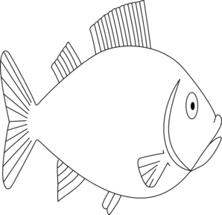

**Precambrian**

**Time**

**Paleozoic**

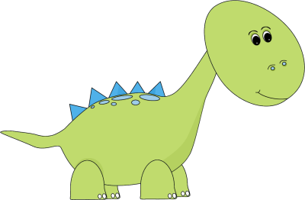



**Mesozoic**

**Cenozoic**