The two processes that treat waste water are treatment plants of sewage systems and septic tank systems. Use the diagram below to compare and contrast the two water systems

Water Treatment Septic System
Scuba divers | Submarines | Remotely Operated Vechiles

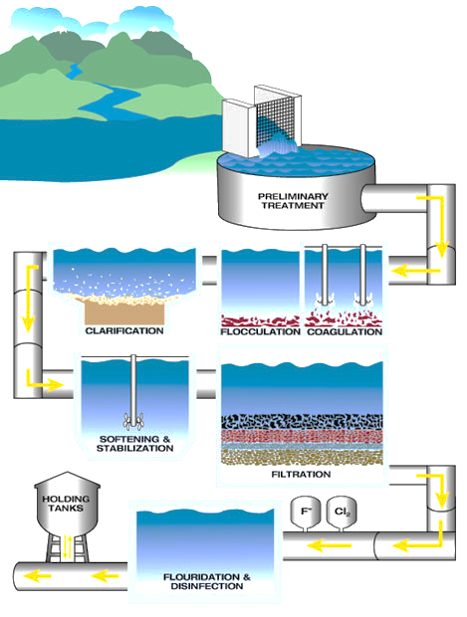
#1 What’s happening at this step:
Water Treatment Process
#2 What’s happening at this step:
#5 What’s happening at this step:
#4 What’s happening at this step:
#3 What’s happening at this step:
3..
4.
2.
1.
5.

